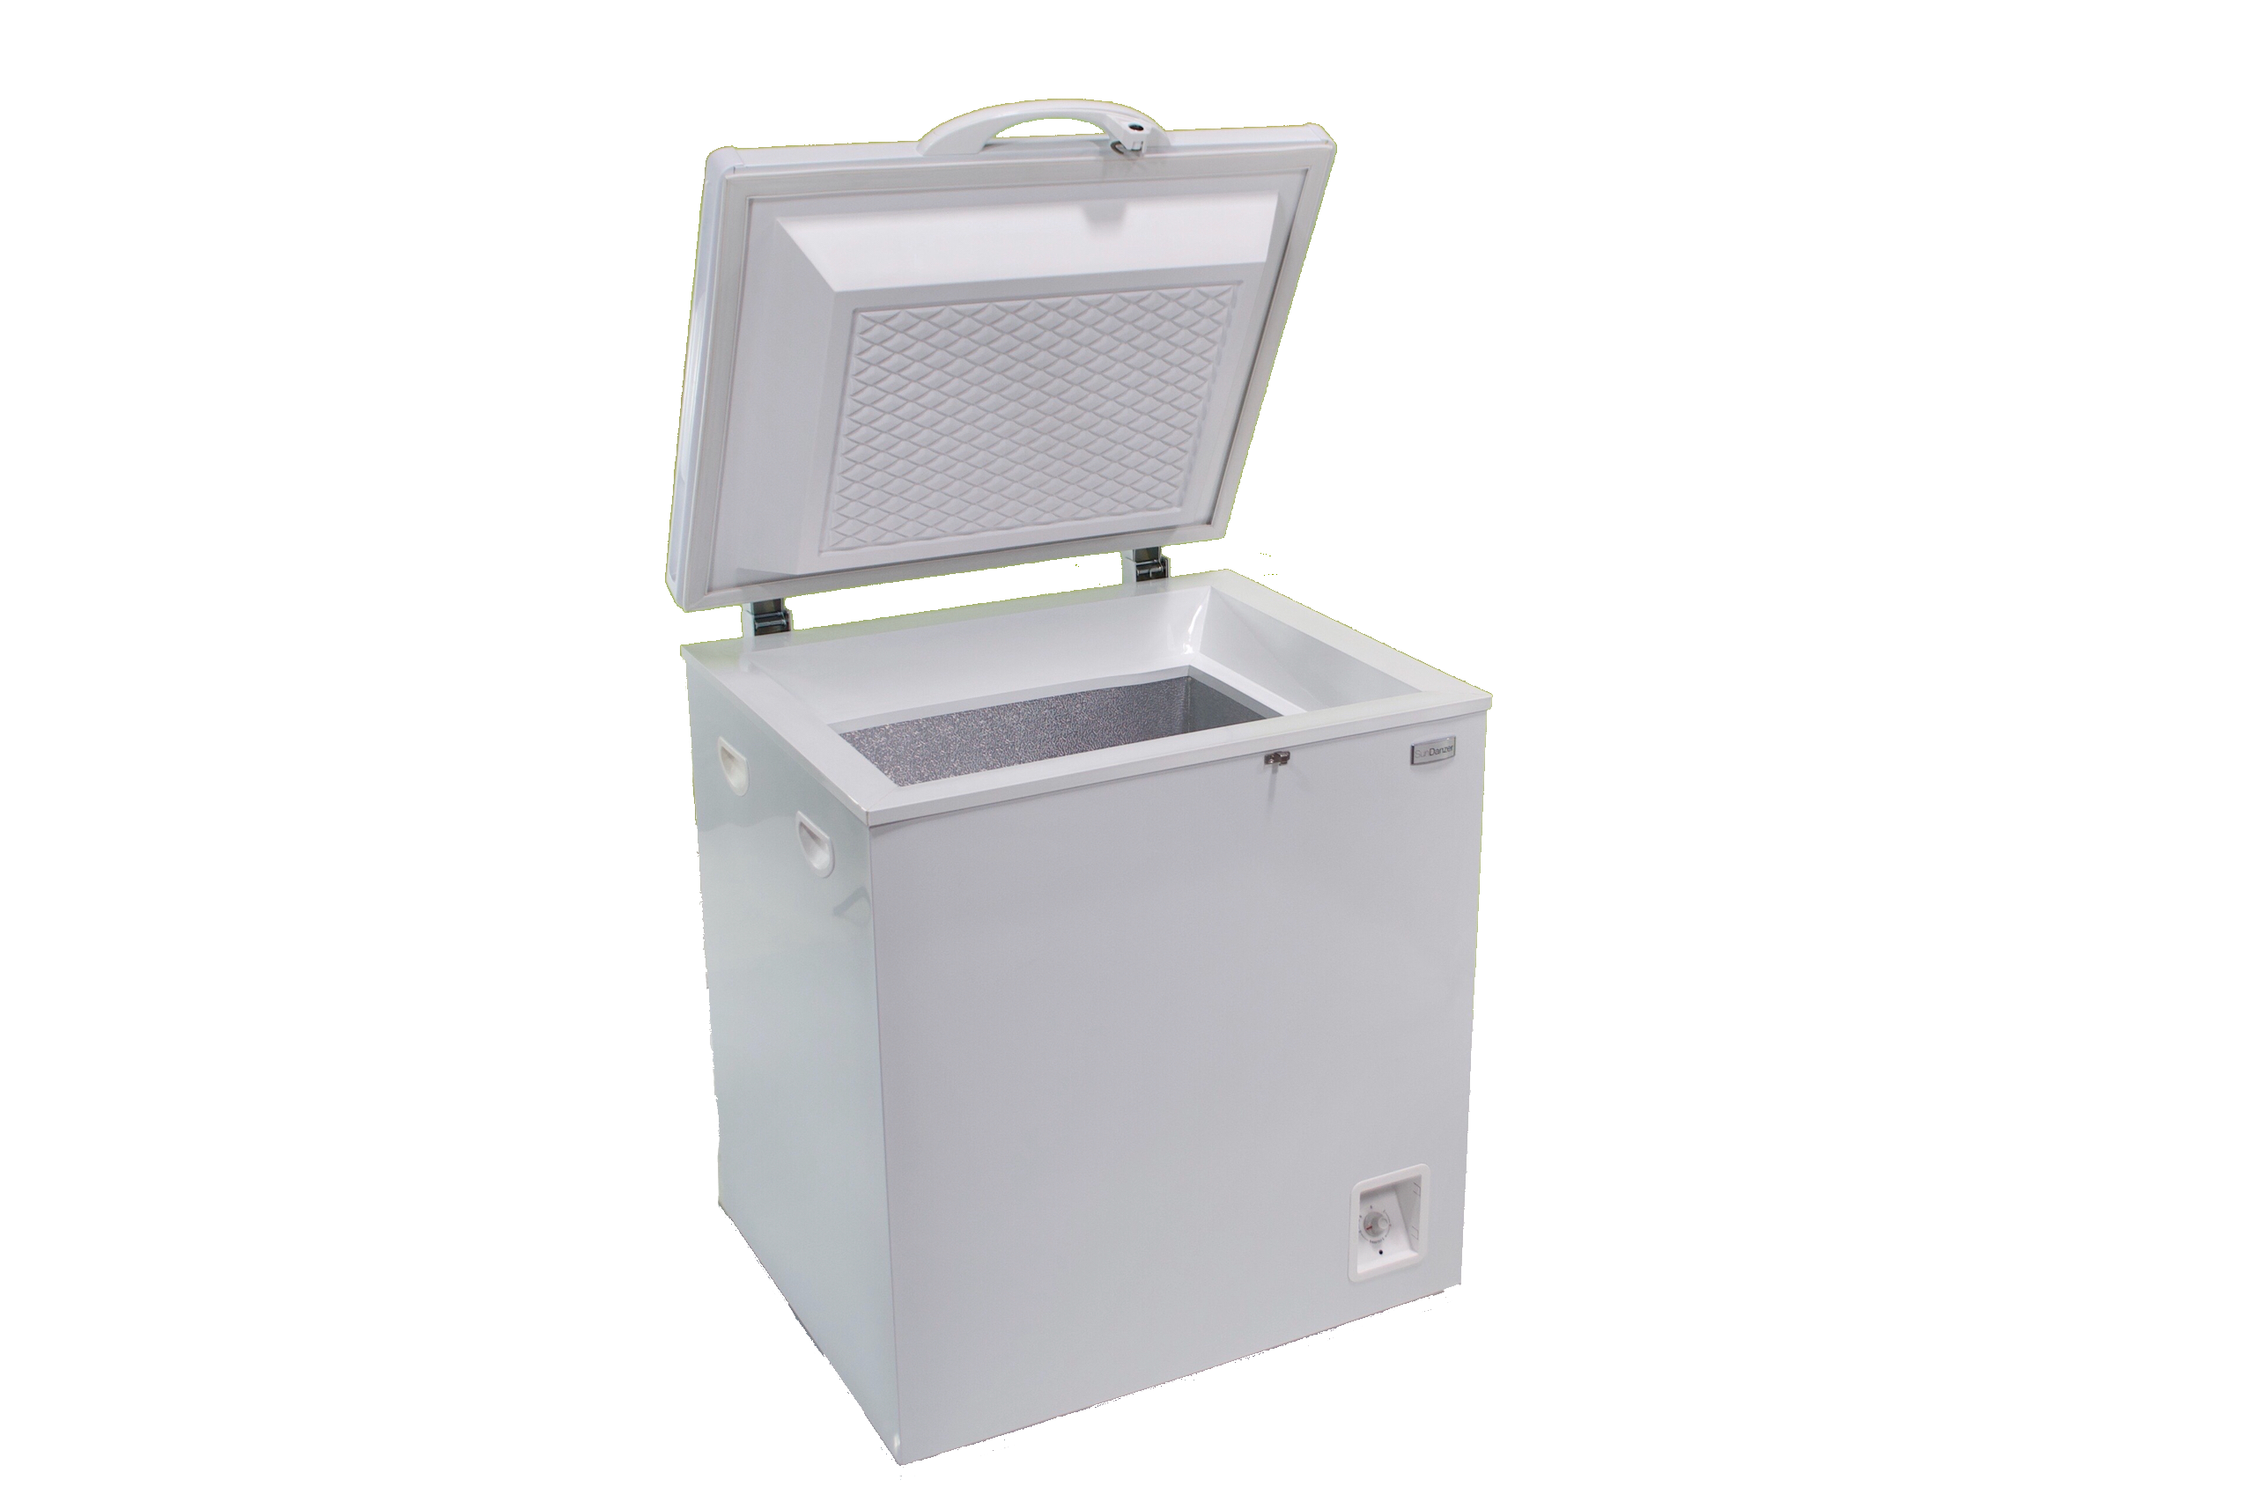

Features:

- Available as fridge or freezer
- < 5W average power draw at 38F operation in 90F ambient
- 4.3 in. of Polyurethane Insulation
- Scratch resistant galvanized steel exterior
- Easy to clean aluminum interior with drain
- Vacuum break for easy opening
- Automatic 12 or 24VDC operation
- Simple design for worldwide service
- 2-year limited warranty

MSRP $1,099
2-Year Limited Warranty
(PV not included)

Off-Grid DC
Refrigerator or Freezer
Alternative to Propane Refrigeration

Since 1999, SunDanzer Refrigeration has designed and assembled solar refrigerators in the United States. Low energy consumption is the key that allows SunDanzer refrigerators and freezers to be powered from alternative energy systems. This approach allows refrigeration in remote locations where it was previously unavailable or too costly. With DC power, no inverter is needed, providing more reliable refrigeration.

Applications:

• Off-grid homes • Micro-enterprises
• Remote stores • Medical clinics
• Disaster preparedness • Farms & ranches
• Unreliable grid power • Missionary homes

Specifications:

Volume | 1.8 ft³ [50 L]
Refrigerator | 30 to 48° F
Freezer | 0 to 23° F
Ambient range | 50° F to 110° F
Voltage range | 10 to 31 VDC
Refrigerator in 90° F | 0.114 kWh/d
Freezer in 90° F | 0.280 kWh/d
Refrigerant | R-600a
Input Power | 35-60 Watts
Defrost | Manual
External dimensions (L x W x H) | 25.75 x 26.75 x 30.5 in.

